Mock interview -1

Git :

GIT(CLI) –> command line utility to talk to your repository (GIT HUB [central or remote repo]) GITHUB->VCS- (maintain version and restore them any time)

# we should not commit .exe .bin .war (binary) file because this file get once you compile and build your source code

1)Why we need git? What makes git unique from other tools like SVN?

All the code and automation test cases in the project should be placed in SCM like git hub, bit bucket, azure repose (depends on a project) etc, To deal with the scm you have a client tool which is basically a git

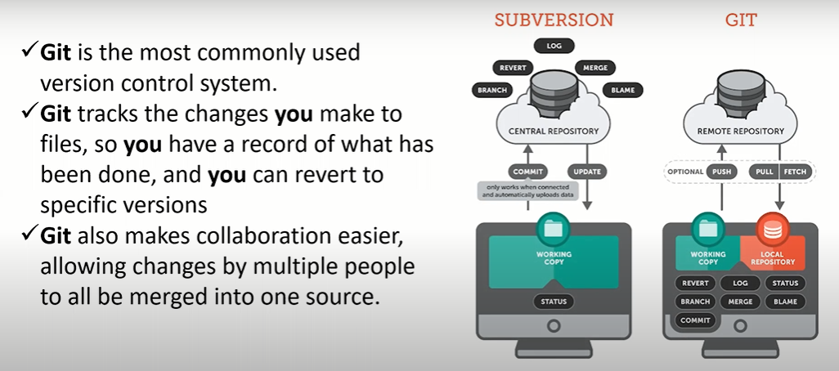why git is better then other SCM because-

There are two types -> Centralized version control system and distributed vestion control system

In CVS – there is server and a client and server is master repository which contain all the version of the code, and in local machine you have working copy but you don’t have something called as a local repository, if you want do any thing like add, commit any operation you should always been online with your central repository and if central repository goes down you won’t able to access your code at all and every thing like log, revert that should be do in central repository.

In DVS- 3 layer architecture like working copy, local repository and remote repository what ever the changes like push pull add in that time only you been online with remote repository and you have local copy in your machine you always work with that and log revert operation you can do it in either local or remote repository.

2)Let's say i have maven repo cloned on to my local, did some changes and i have build the code now target folder will be generated. So now when i do git operations like git add, git commit or any other git operations target folder should not be considered, how would you achieve the same?

We achive this by using git ignore ---- you create a (vi .gitignore) file and place the target dirc in that 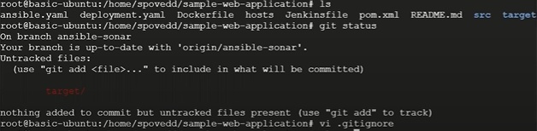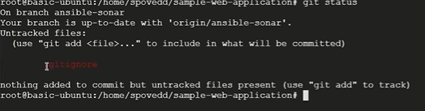 what ever the files foldes are regular expression mentioned, it will ignore with all your git operations

3) difference between git pull and git fetch?

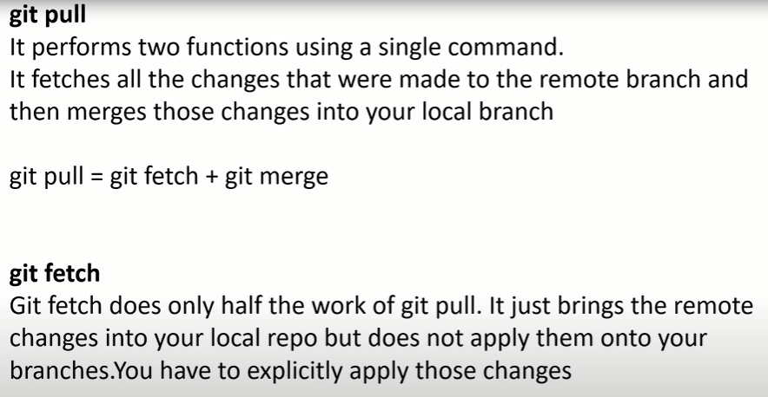

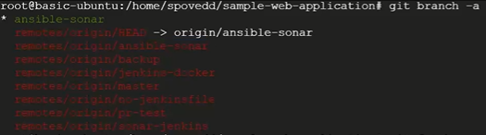when you gone change in the ansible-sonar branch and commit it in github(online), do git fetch instead of git pull in local machine and see the changes it will not applied till now and go to the remote branch git checkout origin/ansible-sonar you can see the changes, that’s what fetch will do it will gone take changes from remote repo and keep it in remote branches in your local, if you want have those changes on your local branch. git checkout ansible-sonar still it is not updated do git merge origin/ansible-sonar it is updated in local branch also

In git pull – both git checkout origin/ansible-sonar and git checkout ansible-sonar changes are applied

4) How to clone specific branch in git?

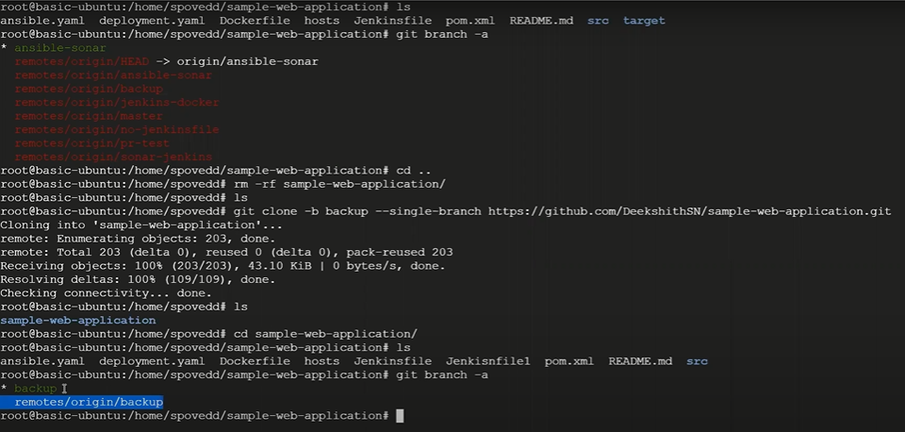

5) Lets say your organization has github and bitbucket to store code, you have cloned a repo onto your local and changed directory name. after some days one of your team members asks you to share clone link, how would you provide the same?

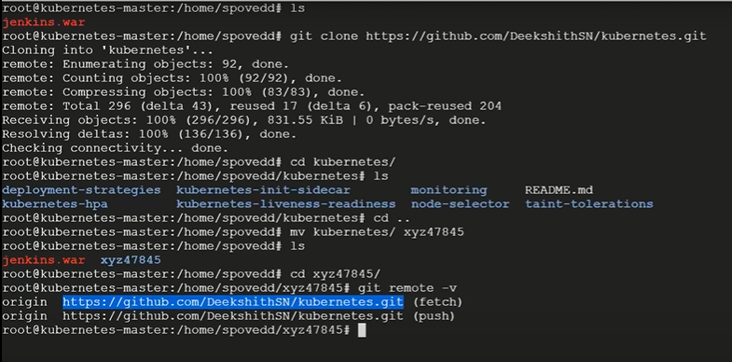

6) I have shell script to delete particular dependency ( repo is maven project ). before running the script i need to clone repo to my local, here point to note i should only clone master branch and only last commit ( last commit has all the code ) how would you do this? 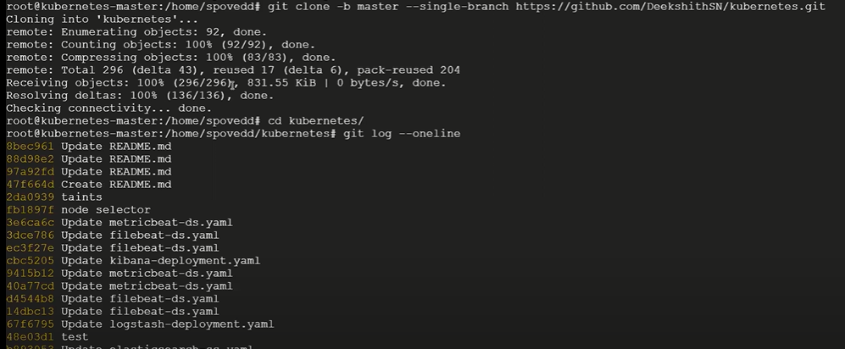

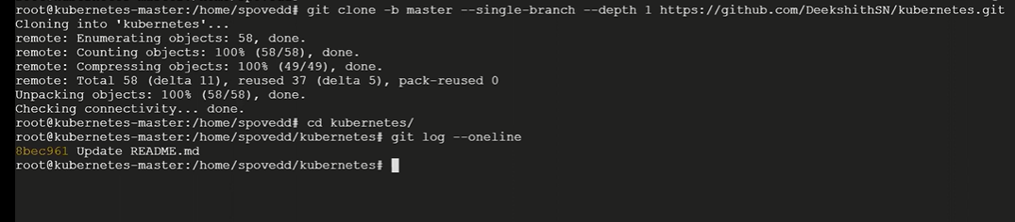 picure one you get lot of commit but in picture 2 you got only one commit

7) what is submodule and why we need submodule?

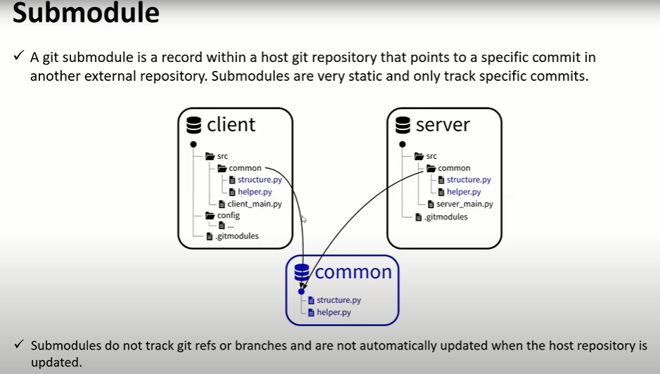

8) Lets say you have changed 5 files a,b,c,d and e in a repo and you did git add ., now all the files are in staging area, now i decided not to commit file d. how would delete it from staging area?

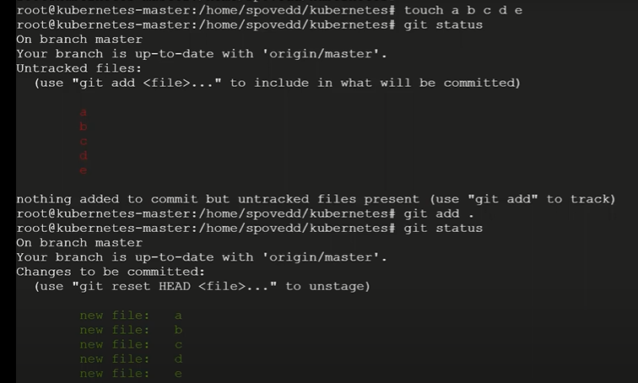

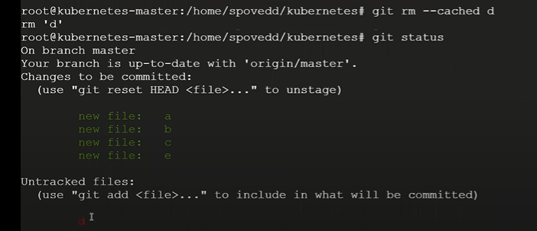

9) What is git-cherry-pick? why we use it?

When ever you want a specific commit, out of any branch you goo for git-cherry-pick

Example- create a branch git checkout –b test fot conformation git branch I am in test branch and create file a (touch a) and add & commit it by git add . & git commit –m “a” switch branch by git checkout ansible-sonar and create file b & c & d ( touch b c d) and add & commit it, and git log –oneline | head you have b commit, c commit, d commit now I need only c commit to my test branch

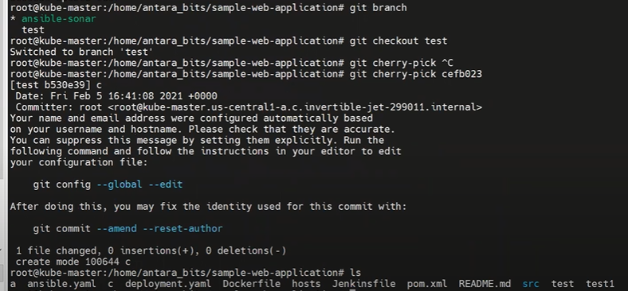

Soo you can get the c file in test branch.

10) Let’s say you’re working on new feature in some branch, now your manager says stop working on that and change few other things on old code. Here after changing the old code, I need to work on new code, so I need to place my new changes some place How would handle this scenario?

Move to test branch edit file a and I don’t want to commit it then 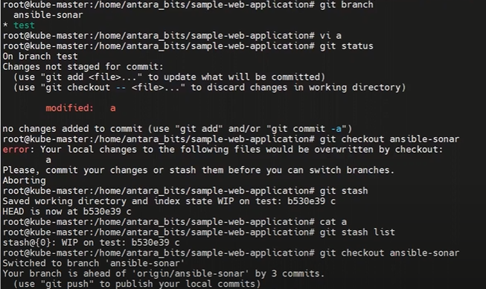

In cat a you can’t see any thing and to find stash is done or not git stash list. 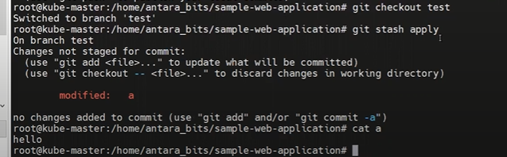in cat a you can see the edited filr a content and you can commit it now

11) What is a conflict in git? 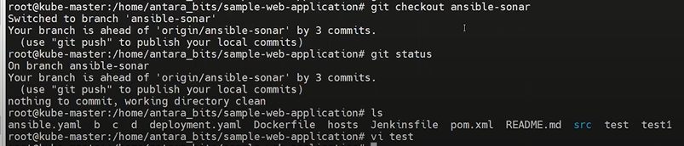 You are in the ansible-sonar branch you edited test file but till not yet added or commited, at the same time somebuddy in your team member change the same file and commited it.

Now I need to git add . & git commit –m “test” & git push ===🡺Rejected it says that there are couple of commit which you want take first and now I take git pull you get a message merge conflict in test 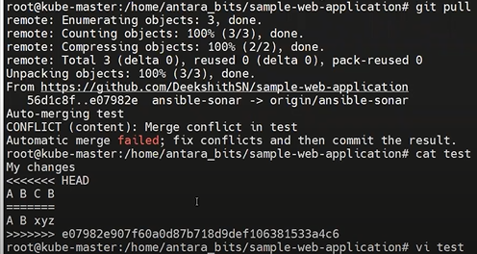 you can make contact with that person what ever the right content in test file you have to place it then you add & commit & push it

12) command to list all branches in a repo? 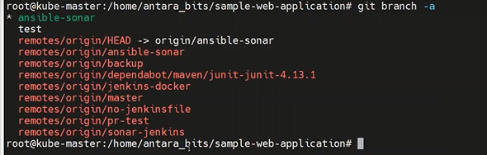

13) What is git reset ? Types of reset ?

Lets assume that I created a.txt & b.txt now added it & commited (commit id is generated), before push it to the remote repository your lead says that, there are few more things need to edit in a.txt and b.txt so whatever the changes that you made you completely ignore it because there is one more developer, who has already worked on it and it has been already to the remote repository, now I want to remove that particular changes that should be commited by me undo those changes in that cases we use reset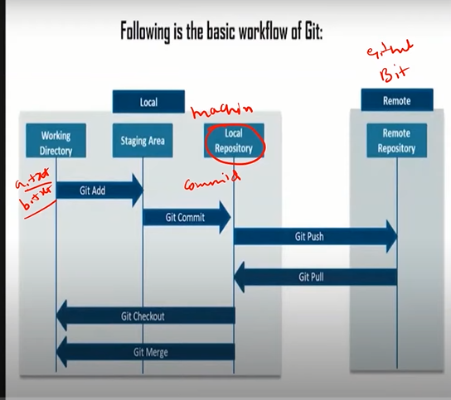 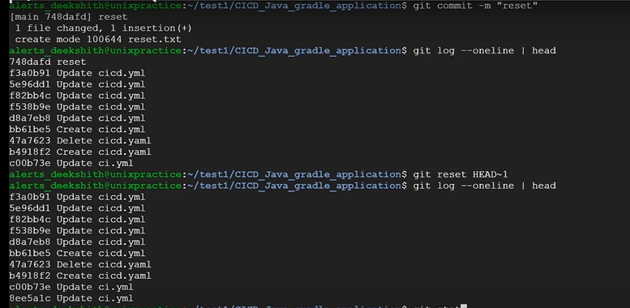

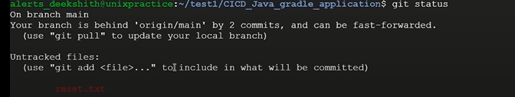

The commit has been deleted but file is still there in local directory if you want ignore that alsoo you have to goo for – hard

1. git reset --hard HEAD~1 ( it will delete commit id & delete the file in working dierectory)
2. git reset --mix HEAD~1 (this is default ( delete the commit id & but still file is in working directory)
3. git reset –soft HEAD~1 (from local repository to get back to staging area) 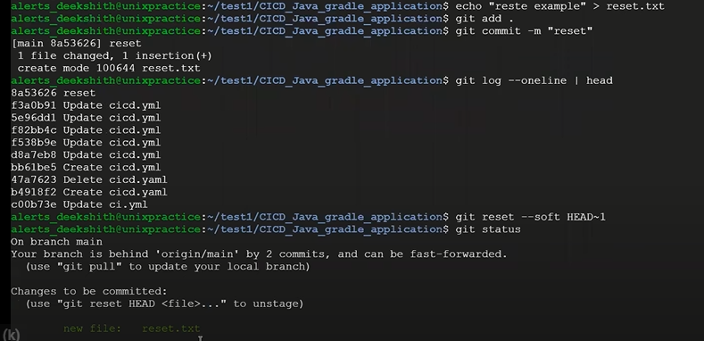

14) How to delete local branch and remote branch in git ? 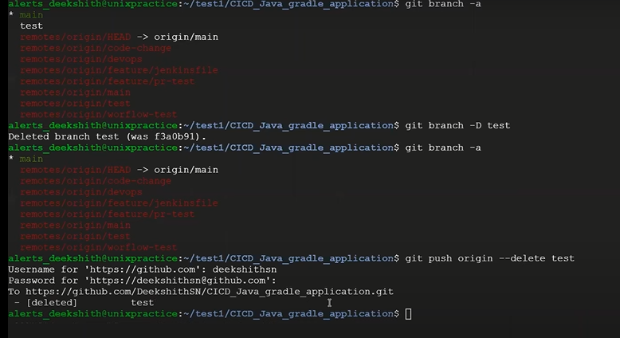

15) Difference between git diff and git status ?

Git diff - to compare 2 file or 2 commit

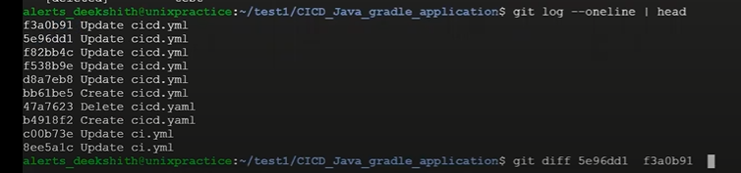

Git status – it will find out the status of the file (which stage my files are there)

16) What are hooks in git?

Hooks are special scripts that could be executed before or after sertain events like commit or push or revert or reset it can be any thing

Example: datree is a tool which find out and tell any missing arguments in kubernetes.yaml file and you have to install command line utility yq & datree. Copy the script in datree website and past it in pre-commit file ( link - <https://hub.datree.io> & INTEGRATION ->Git hooks->copy the script it will gone a red yaml file and verify with respect to some rules )

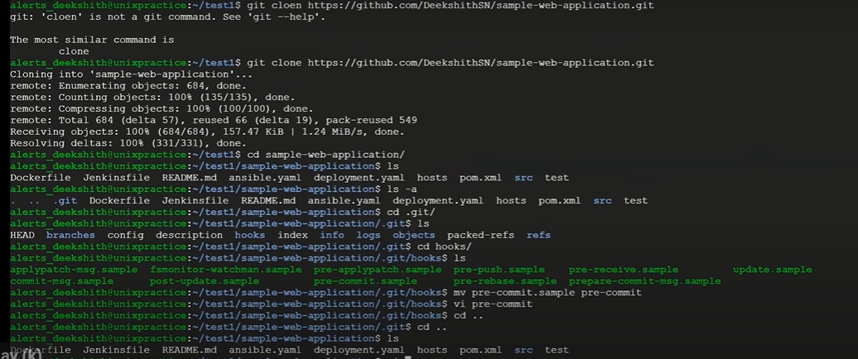

Then edit something in deployment.yaml and add & commit it before commit it will show some error message it is the indication of yaml file not follow some datree rules

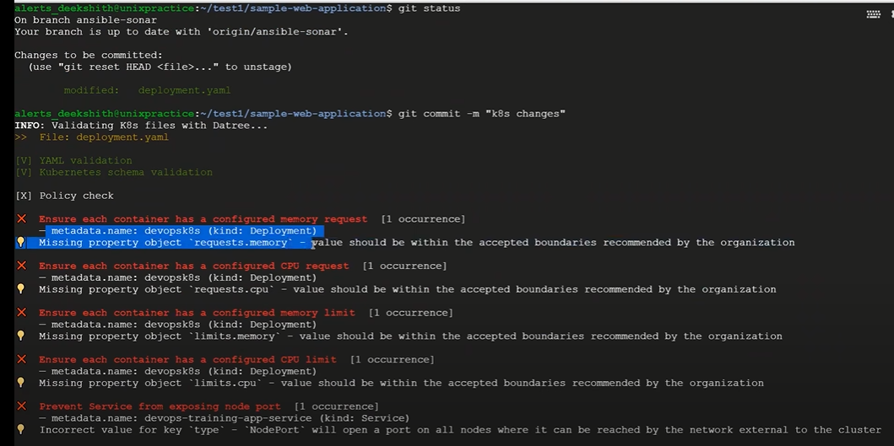 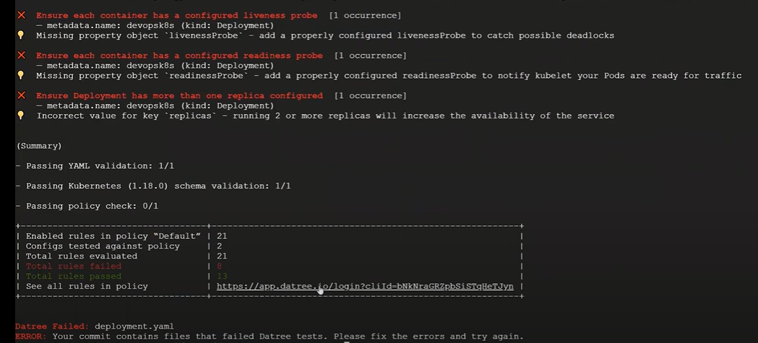

17) what is the importance .git directory?

If you don’t have .git directory you can’t execute any commands because it won’t have any history or any version . It contains branch, hooks, object information etc.

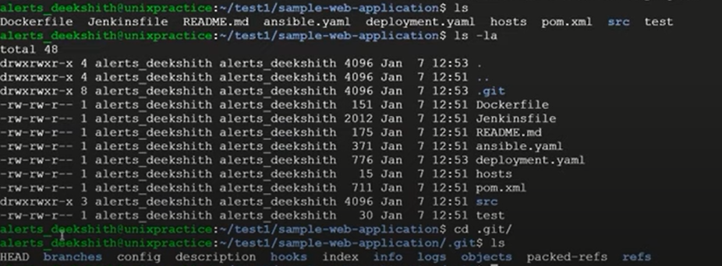

18) what are the branches, diff between remote and local branches?

In simple term we can say that branch is a virtual directory of your existing code itself, your copy of that code virtualy and work on that particular thing and whenever your work is done you can merge it back to master folder/branch

Whichever branched won’t have remote origin in prefix is called local branches, whatever the changes that would do that will be in local branch only it won’t effect your remote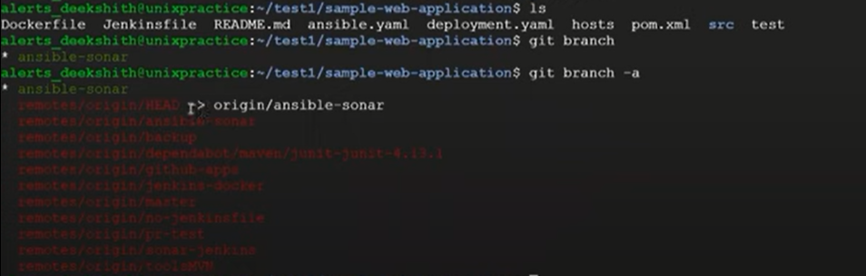

Some other developer who has did the changes you want to take that changes but before taking that changes to my local, I want to validate it and I want check what are all the changes has been done if everything is gone right then I want to take it to my local,

In that case you can use the command git fetch and take the changes on to the remote branch check what are all the changes has been done so once you have ok with that then you merge it back to local branch in those kind of cases you can use remote branches.

19) what Branching strategy that you are familier with? Release activity

In our organization we will going to use main, dev, feature, release and test environment branches. The source code is present main you will get it in dev, if you going to add any functionality to that you will going to create a feature branch and add the functionality and once it successfully done they use to rise something called PR (Pull request) in that they will add reviewers like your senior people, they will going to check that what are the changes you made and weather it is correct or not and validate it in ci-cd pipeline also, once it is successfully run with all the test cases and you get the approval, then that changes will be merge back to dev branch and then they will take the code from this dev branch and deploy to diff environment like uat, qa, prepode everything is tested successfully then we use to merge it back to main and from the main they will create a release branch so from release branch they use to deploy on to production and also if any issues comes in production they use to create bugfix or hotfix branch they will do the small changes and merge it back to this release branch, once the project is successfully running and there are any other commit happen to this release, right again they will rise PR against master they will get the changes back one of the common branching strategy

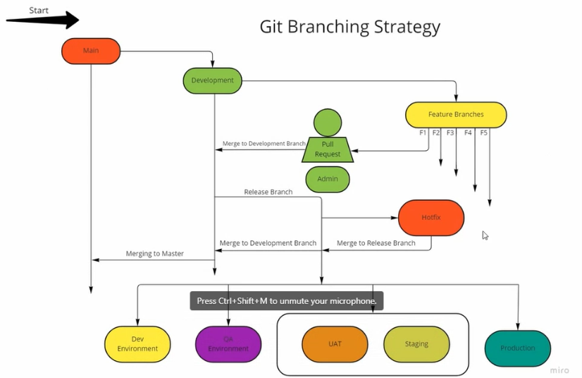

20)What PR (Pull request) is? whats the importance of PR? See video 59:00 to 1:04 (imp)

=>You are saying someone to pull your request (someone is verifying your changes then only they will merging into the master)

# When you have dev changes you are pusing them to the remote then remote has dev changes and master changes so know you will create a pull request from dev to master

Then only changes are merged from dev to master Not branch

Note: -- master is protected branch you can delete and push to that branch

21) Which version of git you have used?

22) What is git squash?

It is not a command, this is an option in a git rebase and also in git merge command ( to make sure git history clean use this squash)– let say for example you’re in 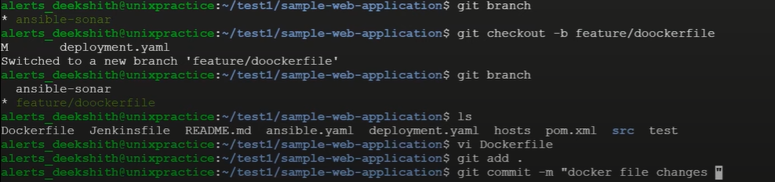

Done some changes in the Dockerfile and test and committed it (2 changes) look at what are all changes git log –oneline | head get last 10 commit id (2 changes I have done) ultimately what are the changes I done in this branch I need to apply to base branch you can do merge but problem is all this commits also copied to base branch but I don’t want all this commit id or commit message to my base branch I want to take that 20 commit id as one commit id to the base branch that’s where we can use this squash 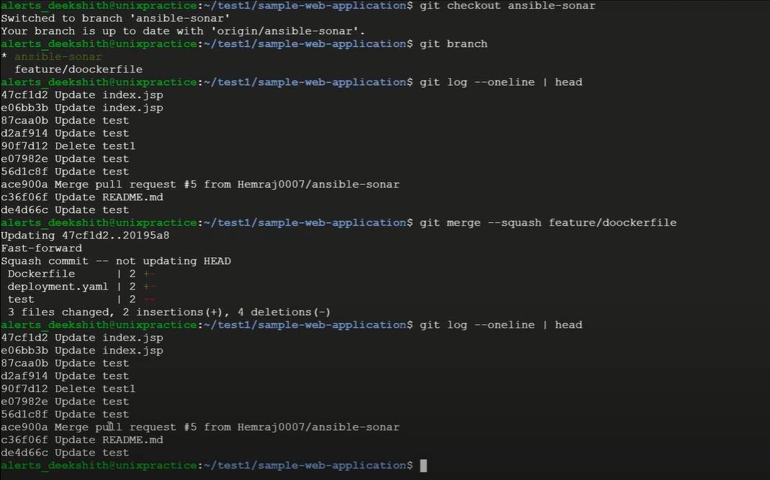one commit id is not appearing but changes for Dockerfile and test file applied.

23) Command to list all commits?

git log -> full information or git log –oneline | head

24) Difference between git merge and git rebase?